**Figure 1.** Characterization of food-emissions between continents.

Memo: Graphs consider aggregate emissions from 1990 to 2015.

Source: Authors construction from EDGAR-FOOD data.

**Figure 2.** Trends in food-related emissions in South America

Source: Authors with data from EDGAR-FOOD.

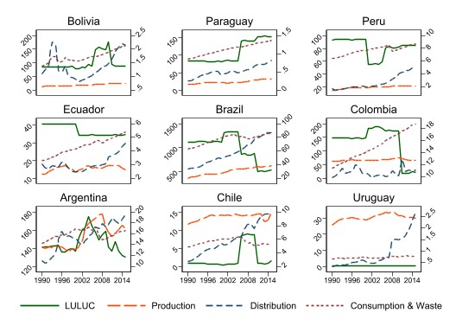

**Figure 3.** Trends in food-related emissions in South America, by subsector

Memo: Emissions in MtCO2eq

Memo: Distribution emissions are the sum of processing, packaging, transport, and retail emissions

Memo: The right vertical axis is rescaled to make visible the trends in "Distribution" and "Consumption & Waste" sectors, but it should be noted that in most countries LULUC and production emissions (left vertical axis) are approximately 10 times higher.

Source: Authors with data from EDGAR-FOOD.

**Figure 4.** Country-year correlations between Foreign Direct Investment and Real Minimum Wages, Economic Freedom, Energy per capita and Logistics Performance.

Memo: Real minimum wages are expressed in 2015 dollars, Energy per capita in kWh, Logistics Performance corresponds to the Overall Score of the World Bank’s Index, and Economic Freedom to the Overall Score of the Heritage Foundation’s Index.

Source: World Bank, Our World in Data and Heritage Foundation.

**Figure 5.** Relation over time between Foreign Direct Investment (as % of GDP) and Main Emissions in the nine countries in sample

Memo: Main Emissions are those that tend to grow over time in the different countries; they correspond in all cases to non-LULUC emissions, except in Bolivia and Paraguay, where LULUC emissions are included.

Source: Authors with data from EDGAR-FOOD and World Bank.

**Table 1:** Group patterns in the relation between Foreign Direct Investment, Emissions, Minimum Wages, Economic Freedom, Logistics Performance and Fuel Exports.

|  |  |  |  |  |  |  |
| --- | --- | --- | --- | --- | --- | --- |
| Countries  (Sorted from highest to lowest FDI-Emissions correlation) | FDI (percentage of GDP, 1990-2015 average) | Fuel exports  (% of total exports,  (1993-2015 average) | Real Minimum Wages  (1995-2001 average, in 2015 dollars) | Economic Freedom  (Index score, 1995-2015 average) | Logistics Performance  (Index score, 2007-2014 average) | Percentage change in distribution emissions  (1990-2015) |
| Chile | 6.4 | 1.1 | 338 | 77.55 | 3.17 | 263 |
| Uruguay | 3.2 | 1.7 | 285 | 68.68 | 2.75 | 695 |
| Colombia | 3.0 | 41.7 | 271 | 63.90 | 2.71 | 14 |
| Brazil | 2.5 | 5.0 | 282 | 59.08 | 3.03 | 160 |
| Peru | 3.7 | 7.5 | 223 | 65.36 | 2.84 | 206 |
| Paraguay | 1.3 | 25.6 | 379 | 59.20 | 2.60 | 213 |
| Argentina | 2.3 | 11 | 446 | 54.44 | 3.04 | 76 |
| Ecuador | 1.5 | 46.4 | 262 | 52.22 | 2.71 | 49 |
| Bolivia | 4.2 | 30.8 | 128 | 56.65 | 2.48 | 97 |
| Sample mean | **3.1** | **19** | **290** | **61.9** | **2.81** | **197** |

Memo: Data on Fuel Exports in Paraguay must be considered carefully. They do not strictly reflect "fuel" exports. Before 2000, the share of fuel exports was 0.15% or less. The increases after that period are explained by the incorporation of electric current to the measurement methodology. Paraguay is currently the largest exporter of electrical energy (hydroelectric production): it consumes 15 billion kWh annually, out of a total annual production of 63 billion kWh. The rest is exported to Argentina, Brazil, and Uruguay.

Source: Authors’ elaboration with data from EDGAR-FOOD, World Bank, Country Economy, Federal Reserve Bank of St. Louis, Heritage Foundation and Our World in Data